# Sound, Sensors and Crypto Test 1

What is the name of B in the diagram below?

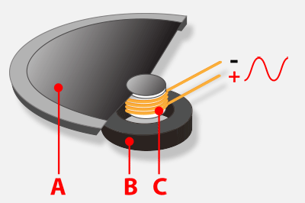

A. Cone

B. Current

C. Magnet

D. Sound wave

ANSWER: C

The code below has been used to develop a tune in Python. What is the name of the data structure?

**tune = ["C4:4", "D4:4"]**

A. Array

B. List

C. Variable

D. String

ANSWER: B

What would the following code output?

shopping = [“apples”, “bread”, “cake”, ”banana”]

print (shopping[0])

A. shopping[0]

B. Error

C. apples

D. bread

ANSWER: C

If you change the pitch of a sound what does this alter?

A. How quickly the sound is played

B. How loud or quiet the sound is

C. How high or low the voice sounds

D. How relaxed or tense the voice is

ANSWER: C

Which command imports the library which enables the microbit to speak?

A. import speak

B. import talk

C. import vocal

D. import speech

ANSWER: D

What is the purpose of encryption?

A. To stop people intercepting data

B. To stop people stealing data

C. To allow data to be sent over the Internet

D. To stop people from understanding intercepted data

ANSWER: D

The Caesar cipher shifts letters along the alphabet. With a right shift of 3, what would the cipher text be for ‘code’?

A. CAR

B. FDU

C. fdu

D. ZXO

ANSWER: B

Using the key below, what would the message ‘9 16 16 19 2 26’ be?

|  |  |  |  |  |  |  |  |  |  |  |  |  |
| --- | --- | --- | --- | --- | --- | --- | --- | --- | --- | --- | --- | --- |
| **A** | **B** | **C** | **D** | **E** | **F** | **G** | **H** | **I** | **J** | **K** | **L** | **M** |
| 2 | 3 | 4 | 5 | 6 | 7 | 8 | 9 | 10 | 11 | 12 | 13 | 14 |

|  |  |  |  |  |  |  |  |  |  |  |  |  |
| --- | --- | --- | --- | --- | --- | --- | --- | --- | --- | --- | --- | --- |
| **N** | **O** | **P** | **Q** | **R** | **S** | **T** | **U** | **V** | **W** | **X** | **Y** | **Z** |
| 15 | 16 | 17 | 18 | 19 | 20 | 21 | 22 | 23 | 24 | 25 | 26 | 1 |

A. HOORAY

B. 9 16 16 19 2 26

C. YAROOH

D. MICROB

ANSWER: B

What is the name of the highlighted sensor which uses an electrode hitting the left hand side to determine a left tilt?



A. Tilt switch

B. Electrode sensor

C. Compass

D. Accelerometer

ANSWER: D

In which direction does the magnetised metal indicator in a compass always point towards?

A. West

B. South

C. East

D. North

ANSWER: D

What is the purpose of the line of code below?

compass.calibrate()

A. To turn on the compass

B. To take a number of readings and set the correct north position

C. To display the direction you are facing

D. To install the compass module

ANSWER: B

What is the name of the variable in the code below which stores the compass reading?

from microbit import *

compass.calibrate()

while True:

needle = ((15 - compass.heading()) // 30) % 12

display.show(Image.ALL_CLOCKS[needle])

A. compass.heading()

B. compass

C. display.show

D. needle

ANSWER: B

Which axis is used to detect whether a microbit is being tilted left or right?

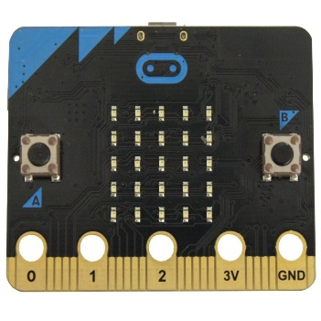

A. X

B. Y

C. Z

D. All of the above

ANSWER: A

Which of the following could be the velocity?

A. 25 kph

B. 25 kph East

C. 25 mph

D. 2 minutes East

ANSWER: B

Which note will be played first if button A is pressed?

tune = ["C4:6", "D4:4", “C4:4”]

tune2 = ["C8:4", "E4:4", “C2:5”]

while True:

if button_a.is_pressed():

music.play(tune)

elif button_b.is_pressed():

music.play(tune2)

A. 4

B. C in octave 6

C. C in octave 4

D. C in octave 8

ANSWER: C

Which of the following could be used as a true random number?

A. A number generated by an algorithm

B. A number generated based upon a pattern

C. A number based on electromagnetic field measurements

D. A number generated by Python using the random number library

ANSWER: C

In the code below, what will be displayed if reading = 20?

from microbit import *

while True:

reading = accelerometer.get_x()

if reading > 20:

display.show("R")

elif reading < -20:

display.show("L")

else:

display.show("-")

A. R

B. L

C. -

D. “-“

ANSWER: C

Jerome has tested the code below but cannot get it to work with all tests. What does he need to do to correct the error?

from microbit import *

while True:

gesture = accelerometer.current_gesture()

if gesture == "right"

display.show(Image.ARROW_E)

elif gesture == left:

display.show(Image.ARROW_W)

else:

display.show(Image.SKULL)

A. Change all == to =

B. Change left to “left”

C. Change else: to elif:

D. Change gesture = to gesture ==

ANSWER: B

In the code below what would be output if you change ? to “firstname”?

display.show("?")

A. The microbit would display the contents of the variable firstname

B. The microbit would display the text “firstname”

C. The microbit would crash as it is expecting an operation to be included

D. The microbit would display an error message

ANSWER: B

Which of the following is a gesture which is not recognised by the microbit?

A. tilt

B. shake

C. freefall

D. face up

ANSWER: A